OBJECTIVE QUESTIONS

Q1. In analyzing the dataset with Power BI, ensure data cleaning to address inconsistencies and missing values before further analysis.
Answer :
- The Null Values are deleted

- New columns “Days For Delivery” ,”Month” and “Profit” are created

- The blank values in column Reason are replaced with “Not Specified”

Q2. How can we calculate the total revenue generated by all the sales?
Answer : We have given Sales Price and Order Quantity for each order. So, by Sales Price x Order Quantity, we get Revenue per order. Adding the revenue for all orders by the below DAX function, we will get total revenue

Total Revenue =SUM(Data[“Sale Price”])
Which came as

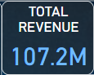

Q3. What is the total number of unique customers who made purchases in each year? Is there any increase in the number over the years?
Answer :

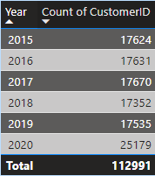

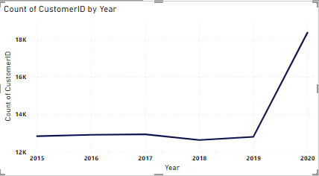

We can see that from year 2019 to 2020, there is a huge rise of 7644 customers as compared to other years.

Q4. How can we determine the total number of unique products available in the company?

Answer: Unique Products = DISTINCTCOUNT(Data[Product])
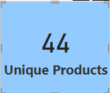

Q5. What is the average number of days it takes for products to be delivered, get the metric for only the delivered orders?
Answer: Avg Days for delivered Orders =
AVERAGEX(FILTER(Data,Data[Status]="Delivered"),Data[Days for Delivery])

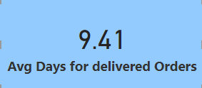

Q6. Which products, categories, and subcategories are the most popular?
Answer: According to the number of Sum Of Order Quantity
Most popular Product : Avon Soft Musk Eau de Toilette Spray - 50ml (14444 Order Qty)
Most Popular Product Category : Health and Beauty (198549 Order Qty)
Most Popular Sub Category : Vitamins and Dietary Supplements (70553 Order Qty)

Q7. Which products have seen an increase or decrease in sales over the year?
Answer : To answer this, the yearly sales growth needs to be found. According to below DAX formula :
Yearly Sales Growth = DIVIDE([Total Revenue],CALCULATE([Total Revenue],DATEADD(Data[OrderDate].[Date],-1,YEAR)),0) -1
Converting the result in percentage and by applying conditional formatting for Red means negative growth and Blue means positive Growth, below are the product wise details

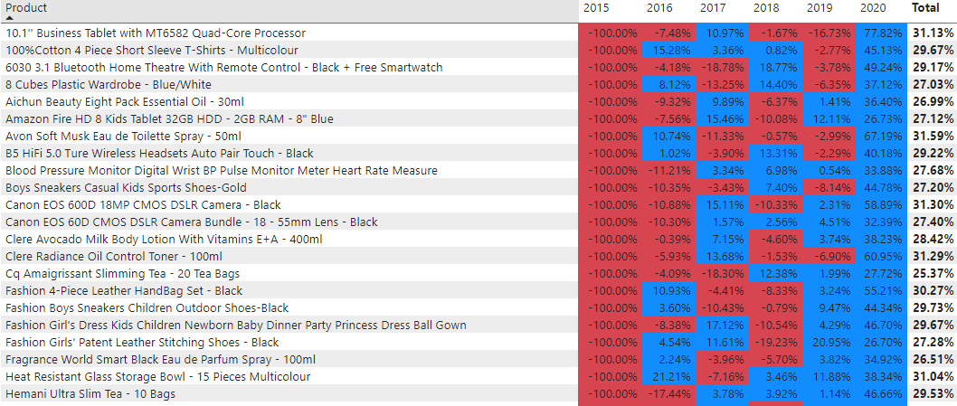

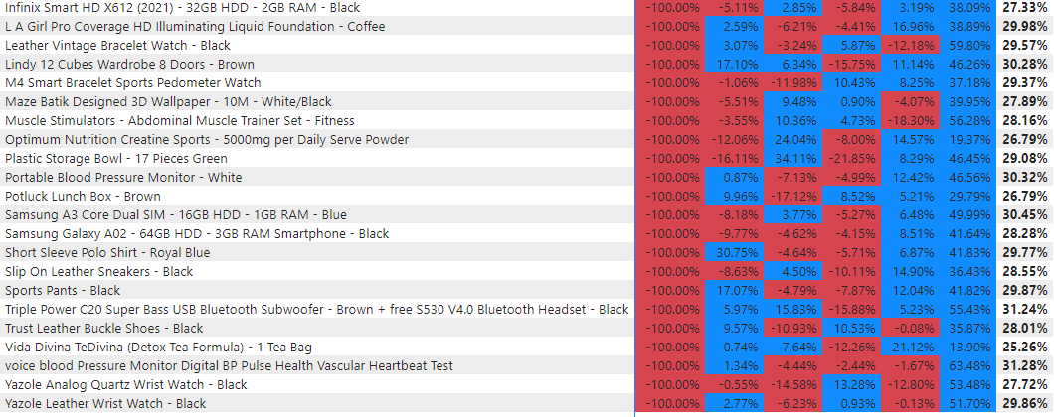

SUBJECTIVE QUESTIONS

Q1. How does revenue break down by year and by-product? Evaluate how different products contribute to annual revenue and come up with suggestions to increase the sales of the low-selling items.
Answer : Revenue by Year :

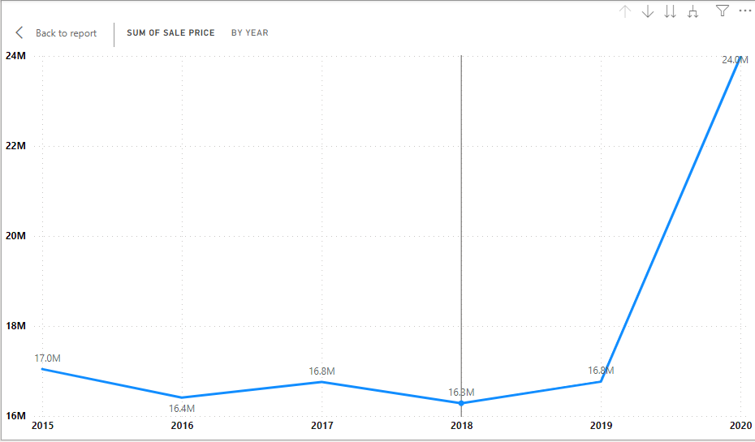
Revenue by Product :

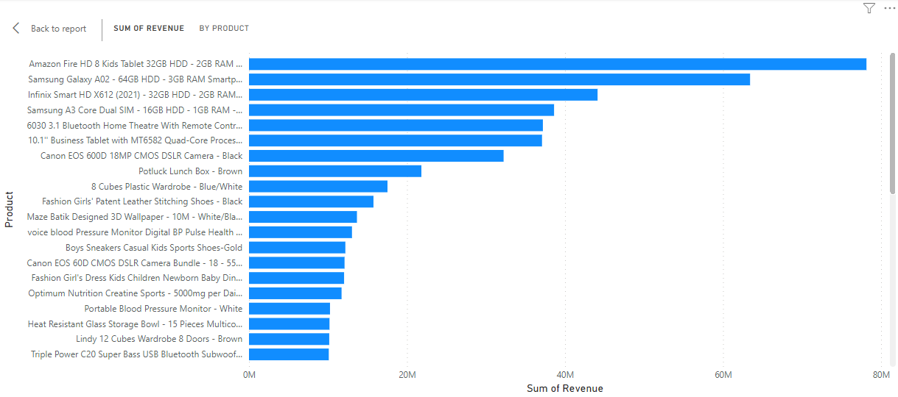
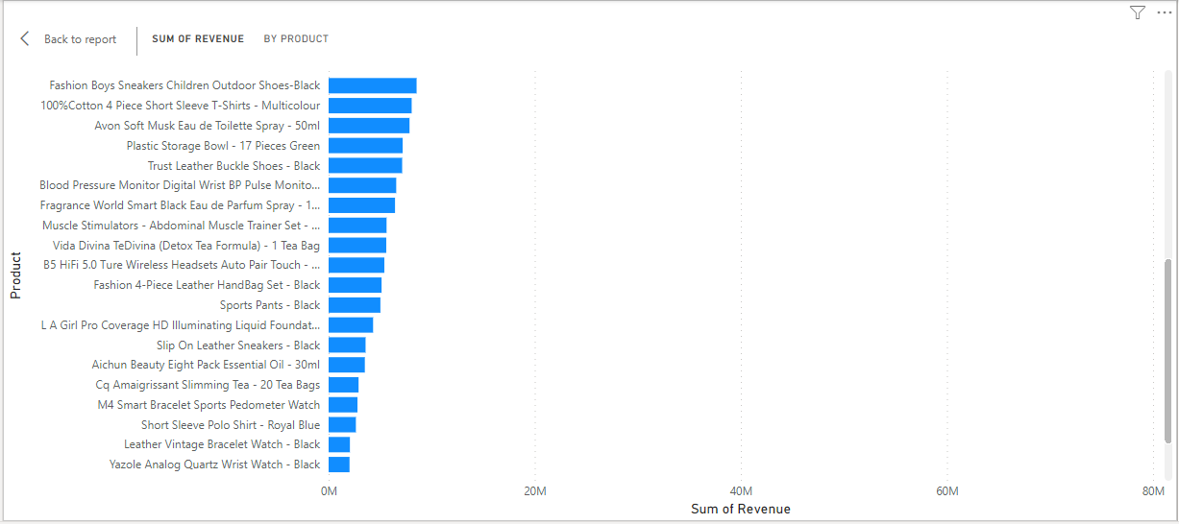
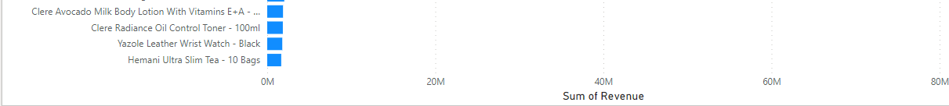

Lets consider the least 3 products :
- Hemani Ultra Slim Tea - 10 Bags

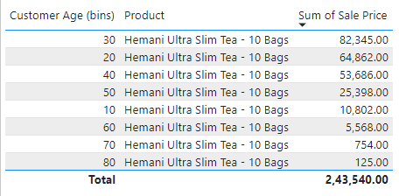

- Clere Radiance Oil Control Toner - 100ml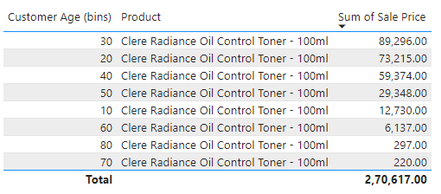

- Yazole Leather Wrist Watch – Black

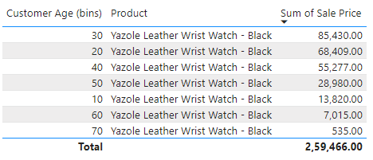
Analyzing above 3 tables, we can see that in higher Age Groups, products are not doing that much great. So, by promoting the products to older people, we can increase our sales.

Q2. How many products were returned? Examine the possible reasons for returns and consider how this metric could inform improvements in product descriptions or quality control.

Answer : Products returned = COUNTX(FILTER(Data,Data[Status]="Returned"),Data[Status])
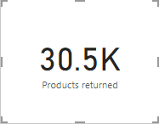

Below are the reasons for returns.
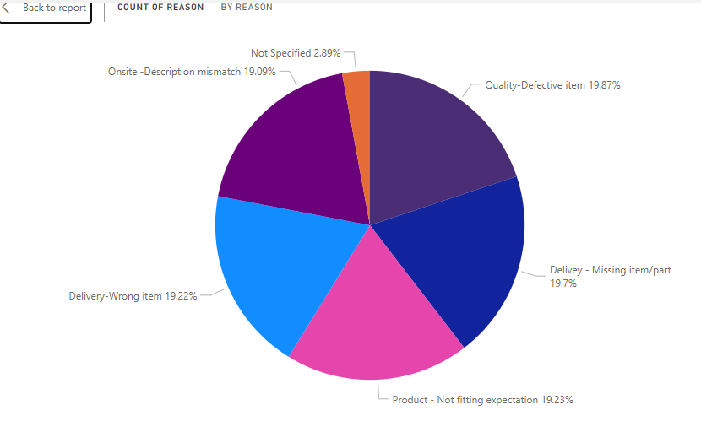

According to the graph above, we can see that below are the reasons for returns

1.Wrong Item
2.Missing item
3.Description Mismatch
4.Product not fitting expectation
5.Defective Item

- Total of 31K products were returned, out of this the distribution of reasons is shown in the chart above, from the chart we can see that almost all the reasons had around the same weightage, there are few orders for which reason is not mentioned, but rest all 5 reasons are around 19%.
- For reasons like defective items, wrong items and missing items, we can take some steps to make sure that sellers will provide good products and services. We can rate sellers, based on their products return ratios to see which seller lacks the quality.

- For Reason like size mismatch, we can provide better size guides than the ones we currently have. We can categorize the sizes as per brand or we can provide insights while the customer is ordering like “ This brand's sizes run generally higher so please select one size smaller “.

Q3. Whenever a customer goes to Amazon, they’ll filter the most rated products in order to buy the better category. Can you verify this using any visualization or table that the ratings of products impact their sales value?
Answer :

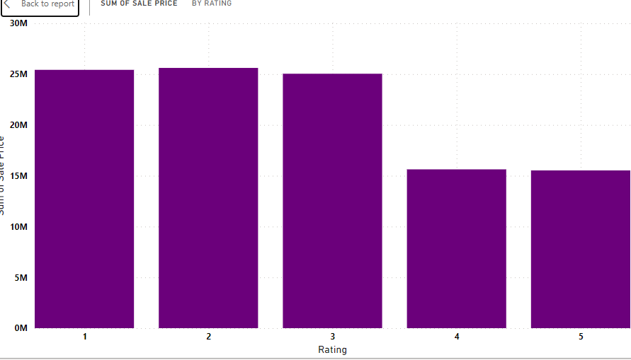

- This chart shows there were more no. of products in ratings 1, 2, 3 and similarly revenue was also higher, so from this visual we can say, products which were rated most, were in first priority of customers.

Q4. Investigate how revenue distribution varies across different locations. Explore which geographical areas contribute most to sales and consider the strategic implications for regional marketing and distribution efforts. How might location-based trends inform the company's approach to market segmentation and resource allocation?

Answer :
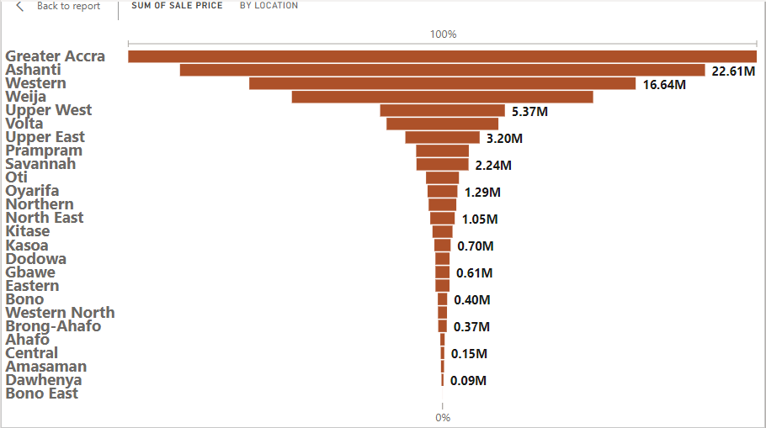

- From this chart we can see that maximum sales came from greater accra, ashanti, western, weija. For locations where revenue was less, we can provide better discounts, we can concentrate more on marketing in that specific locations. We can find products which are not performing well for respective locations and can provide targeted discounts.

Q5. Determine which month could benefit from enhanced promotional offers to boost sales. Can you suggest some targeted marketing strategies here?

Answer : Below chart gives the distribution of average monthly sales over 5 years
By using below DAX measure

Avg monthly sales = AVERAGEX(
SUMMARIZE(Data, Data[OrderDate].[Month], "Total Sales", SUM(Data[Sale Price])),SUM(Data[Sale Price])
)

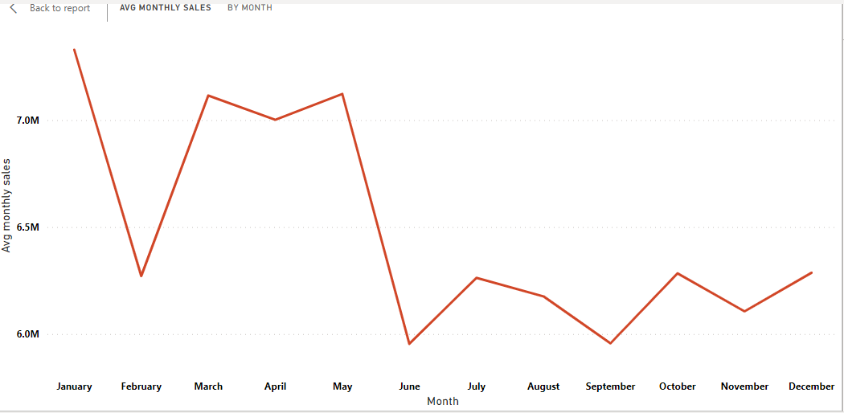

As we can see, there is a significant drop from January to February and the Sales are low from June to December.
So, first we should find the cause of huge drop of sales in February.
Then, we should focus on second half of year from June to December.
We can follow below strategies to boost the sales :

Seasonal promotions: Offer discounts or special deals tailored to the specific needs or preferences of customers during low-performing months.
Bundle promotions: Create bundles or packages of complementary products and offer them at a discounted price to incentivize purchases.
Limited-time offers: Introduce limited-time promotions or flash sales to create a sense of urgency and encourage immediate purchases.
Targeted advertising: Launch targeted marketing campaigns through email, social media, or other channels to promote your promotional offers to the relevant customer segments.
Loyalty programs: Reward loyal customers with exclusive offers or discounts during low-performing months to incentivize repeat purchases and increase customer retention.

Q6. Identify which products may require increased marketing efforts. Which items have high prices yet underperform in sales?

Answer : Here we have a Scatter Plot for each product along with total revenue and Avg Unit Price. Here we can see 4 products which are not in Revenue Trend Line of scatter plot. These are
  - Canon EOS 60D CMOS DSLR Camera Bundle - 18 - 55mm Lens – Black
  - Canon EOS 600D 18MP CMOS DSLR Camera – Black
  - Amazon Fire HD 8 Kids Tablet 32GB HDD - 2GB RAM - 8" Blue
  - Samsung Galaxy A02 - 64GB HDD - 3GB RAM Smartphone – Black

It is clear from the graph that these products have high prices yet underperform in sales

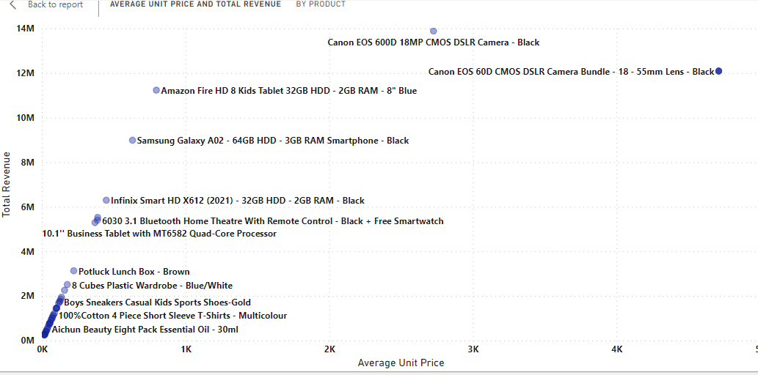

Q7. Assess which products should have discounts. How can targeted incentives drive sales and customer loyalty for specific products?
Answer :
From the graph below, we can see that category “Electronics” has the lowest number of Order quantities

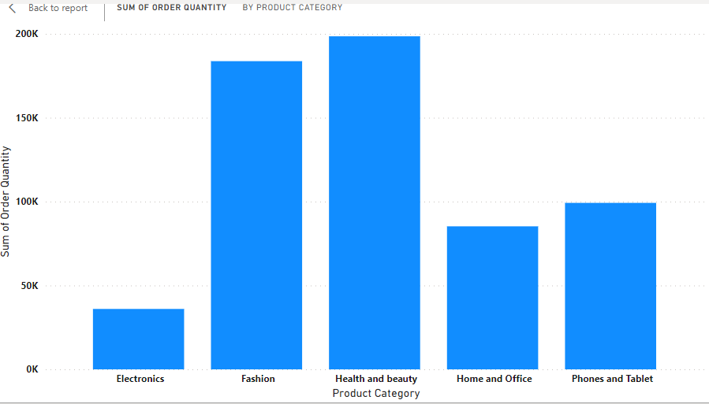

Now comparing the Revenue generation per Category, we can see that Electronics are the second most revenue generating category.

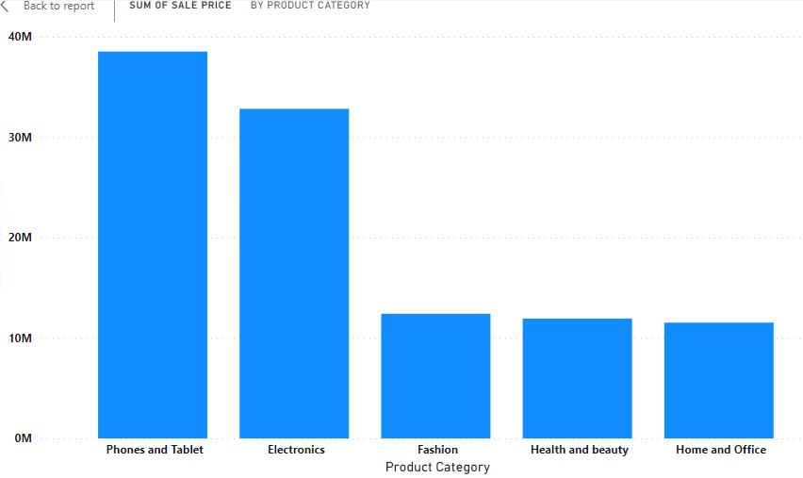

Now comparing the Products in Electronics Category
- By revenue :

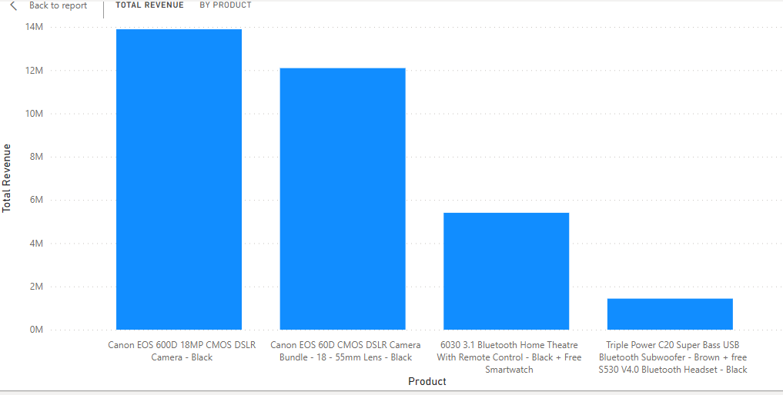

Also, by below table, we can see that Canon Cameras are most costly.
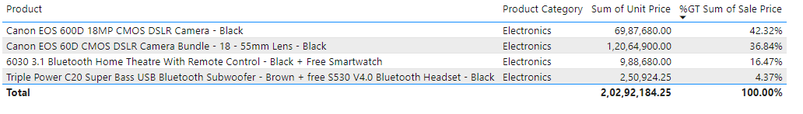

So, if we give discounts on Electronic Products, specially on Canon 60D and Canon 600D cameras, it will increase the sales quantity in Electronics Category and eventually will increase the overall revenue.

Q8. Come up with a loyalty program to benefit the company’s customers. From the available lot of customers come up with strategies to bucket them and provide benefits under different loyalty programs.
Answer : Bucketing the lot of customers on the basis of revenue generated, we get the following table

0-1000
1000-2000
2000-3000
3000-4000
4000-5000
5000-6000
6000-7000
7000-8000
8000+

Plotting the count of customers on the basis of buckets :

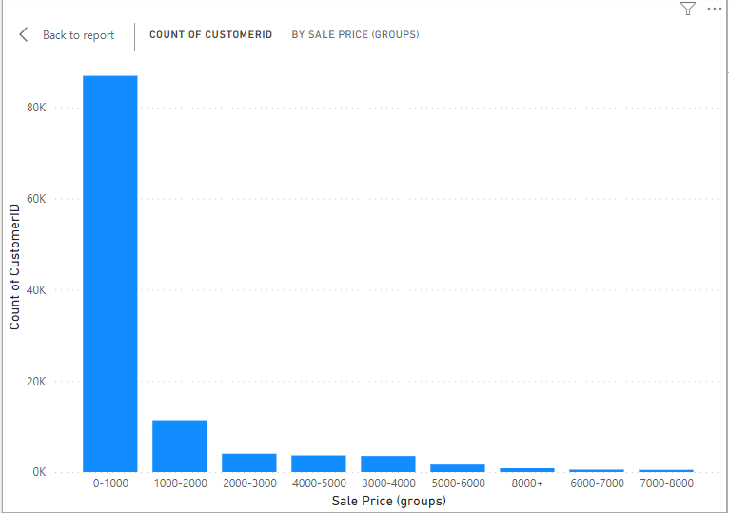

As we can see, we have most of the customers fall under the bucket “0-1000” and a very few of the total comes under “6000-8000”.

Now plotting the graph between the buckets and Revenue by each bucket:
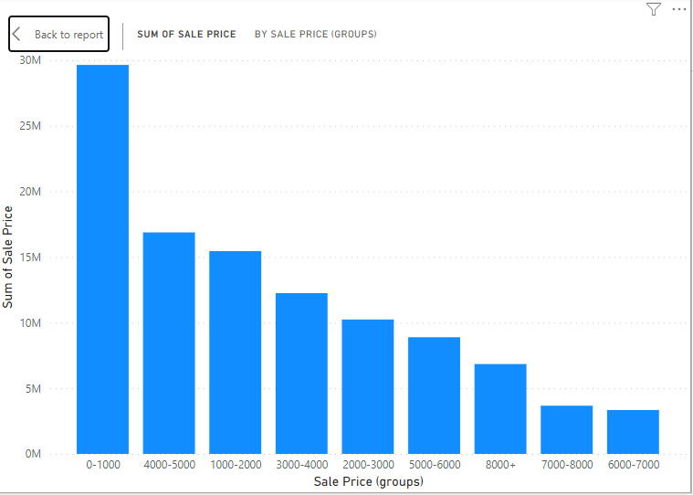

- Most of our Revenue comes from “0-1000”.
- But in the data, each customer is unique. So, we would consider the customers who have purchased the costliest products which falls under 8000+ bucket.
We could provide following offers to our loyal customers :

Exclusive Discounts: Special discounts or promotional offers exclusively for loyal customers.

Reward Points: A reward points system where customers earn points for every purchase they make. They can then redeem these points for discounts, free products, or other rewards.

VIP Services: VIP treatment to loyal customers, such as priority customer support, early access to new products or promotions, or personalized shopping experiences.

Freebies and Gifts: Surprise loyal customers with freebies, samples, or gifts as a token of appreciation for their continued support.

Birthday Discounts: Special birthday discounts or gifts to loyal customers to celebrate their special day.

Exclusive Events: Invite loyal customers to exclusive events, such as product launches, VIP sales events, or meet-and-greets with company executives or brand ambassadors.

Extended Return Periods: Extend the return period for loyal customers to provide them with added flexibility and convenience when making purchases.

Customized Offers: Personalize offers and recommendations based on the purchase history and preferences of loyal customers to make them feel valued and appreciated.
Referral Rewards: Encourage loyal customers to refer their friends and family by offering referral rewards or incentives for successful referrals.
Sneak Peeks and Previews: Provide loyal customers with sneak peeks or previews of upcoming products, collections, or sales before they are available to the general public.
Charitable Donations: Consider donating a portion of sales made by loyal customers to charitable causes or organizations they care about as a way to give back and make a positive impact.
Continuous Engagement: Stay in touch with loyal customers through personalized communications, such as thank-you emails, newsletters, or exclusive content that provides value and keeps them engaged with your brand.

Q9. Wait Times Correlated with Demographics and Care: Explore how average wait times vary across different product categories to optimize scheduling and staffing.

Answer :
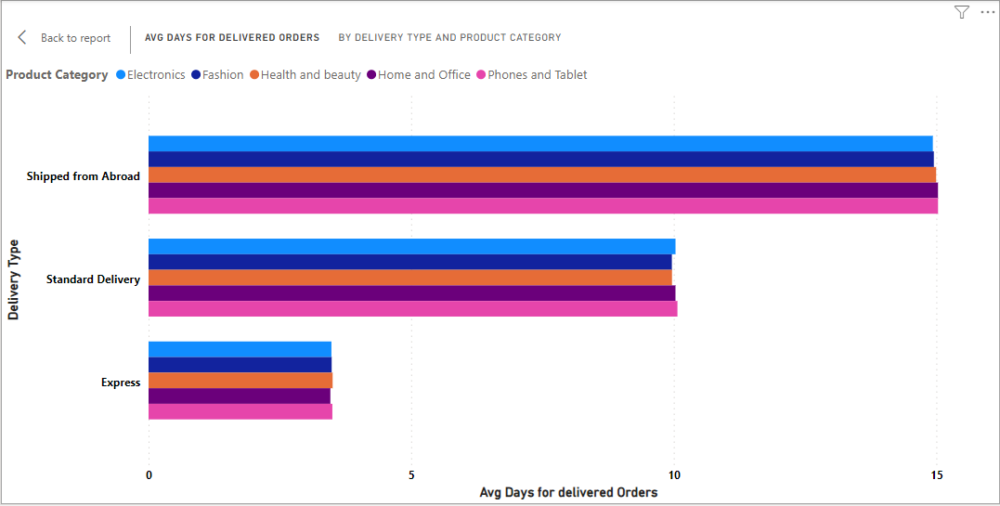
- We can use the above chart to find average delivery days for different product categories, we will also be able to categorise them based on type of shipments.
- We can analyse delivery days for different product categories and type of shipments, to optimise modes of shipments. We can look to open more warehouses at key locations to lower No. of delivery days

Q10. Explore if there is any relationship between the Delivery type and waiting time between ordering and receiving an item.

Answer :

- We can use this same graph to get a relation between waiting days and type of delivery. We can see orders shipped from abroad took maximum days, while express delivery took least time.

Q11. Is there any relationship between shipping charges and product type?

Answer :

- Below chart shows that Health and Beauty / Fashion have the highest shipping Fees.
- This is because the unit price for such products are low as compared to Electronics/Phone and Tablets/Home and Office.
- So to compensate the unit price, shipping fee is high for low unit price products.

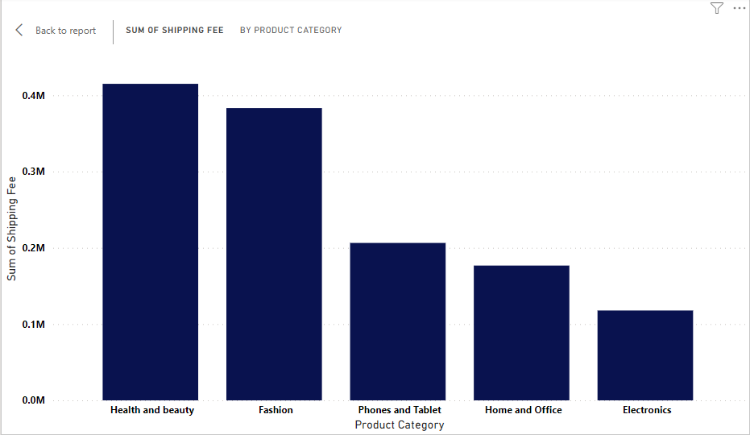

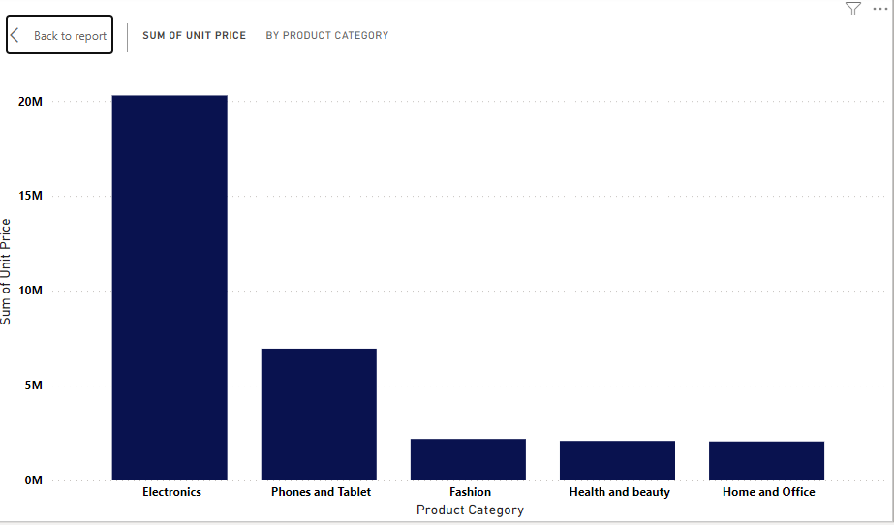

Q12. Come up with strategies to decrease the low rating orders after analyzing different factors like waiting time, shipping type, unit price, etc.

Answer :
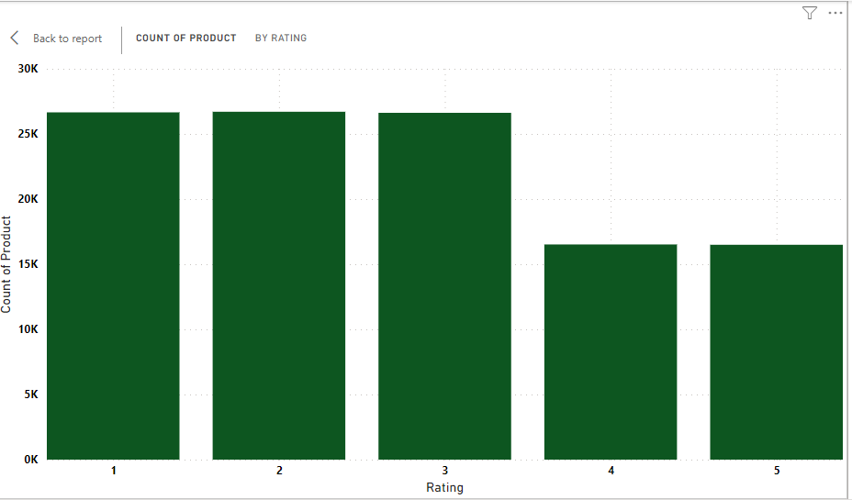

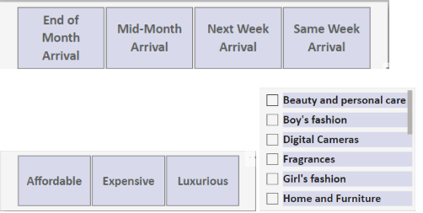

- We can use this chart with these 3 slicers for analyzing low rating products based on waiting time and unit prices (here unit prices and waiting time are grouped into categories).
- There is also a slicer for different sub categories. (The waiting time was directly related to shipping type, so we can get similar ideas from both).
- We can analyze the rating of products under different scenarios to make accurate strategies.

